1. Introduction
The Smart Pantry Manager is an Android mobile application developed using Java in Android Studio. The purpose of the application is to help users manage ingredients that they already have available and suggest recipes that can be prepared using those ingredients.
The application allows users to add, edit and delete pantry items. Each pantry item contains an ingredient name, quantity, unit and an optional expiry date. The pantry information is stored locally using an SQLite database so that the information remains available after the application is closed.
The application also contains a collection of recipes with the ingredients, quantities and preparation steps required for each recipe. A recipe is only suggested when all of its required ingredients are available in the pantry in sufficient quantities. The matching process also handles simple singular and plural ingredient names and basic unit conversions such as kilograms to grams and litres to millilitres.
Additional features include recipe details, input validation, expiring-soon alerts, a settings screen and a navigation menu. These features were developed to create a simple and user-friendly application while meeting the requirements of the Smart Pantry Manager assignment.

2. System Design
2.1 Application Overview
The Smart Pantry Manager was designed as a simple Android application with separate screens for the main functions of the system. The main screen allows the user to navigate to My Pantry, Suggested Recipes and Settings.
The My Pantry screen allows the user to add, edit and delete ingredients. The pantry data is stored in an SQLite database using the DatabaseHelper class. This allows the pantry information to remain saved when the application is closed and reopened.
The Suggested Recipes screen uses the ingredients stored in the pantry to determine which recipes can be prepared. The RecipeMatcher class checks the ingredient name, quantity and unit for every ingredient required by a recipe. A recipe is only displayed when all of its requirements are satisfied.
When a suggested recipe is selected, the Recipe Details screen displays the required ingredients and preparation steps. The Settings screen allows the user to enable or disable expiring-soon alerts for pantry items (Android Tutorial, 2026).
The application uses Java classes for the application logic, XML layouts for the user interface and SQLite for local data storage (Android, 2026).

2.2 Smart Pantry Manager Screen Flow
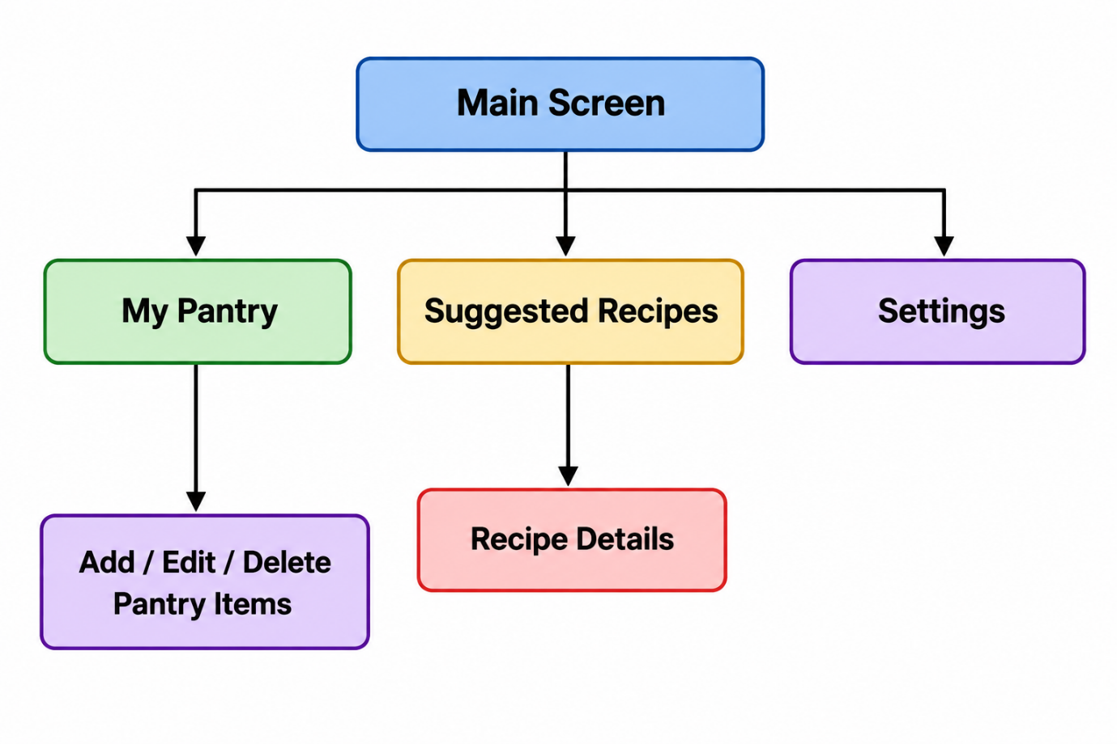

The application starts on the Main Screen. From the Main Screen, the user can open My Pantry, Suggested Recipes or Settings. My Pantry provides the add, edit and delete functions for pantry items. Suggested Recipes displays recipes that match the available pantry ingredients, and selecting a recipe opens the Recipe Details screen. Settings allows the user to control the expiring-soon alert feature.

2.3 Database Design
The Smart Pantry Manager uses an SQLite database called SmartPantry.db to store the application data locally on the Android device. SQLite was selected because it is suitable for Android applications, does not require an external database server and allows the application to work without an internet connection (SQLite DB, 2022).
The database contains three tables: pantry, recipes and recipe_ingredients.
The pantry table stores the ingredients entered by the user, including the ingredient name, quantity, unit and optional expiry date.
The recipes table stores the recipe name and preparation steps. The recipe_ingredients table stores the ingredients required for each recipe, including the required quantity and unit. The recipe_id is used to connect each required ingredient to its recipe.
The application uses the DatabaseHelper class, which extends SQLiteOpenHelper, to create the database and perform the pantry add, read, update and delete operations (SQLite DB, 2022).

2.4 Smart Pantry Manager Entity Relationship Diagram
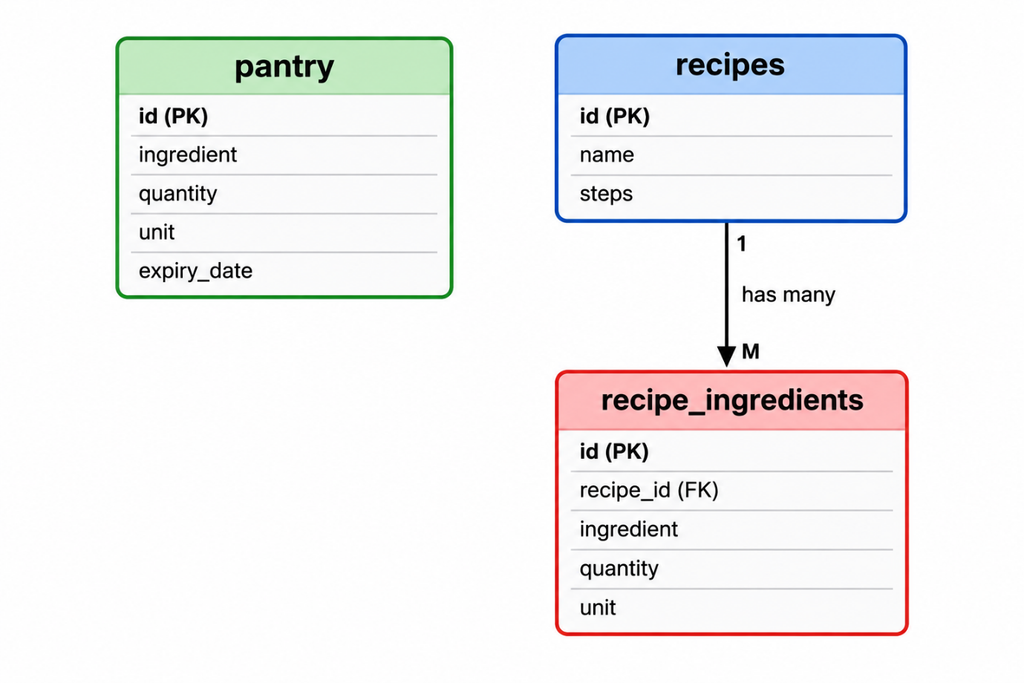

The ER diagram shows the three tables used by the application. The recipes table has a one-to-many relationship with the recipe_ingredients table because one recipe can contain several ingredients. The pantry table stores the user's available ingredients separately. Pantry ingredients are compared with recipe ingredients by the application logic in the RecipeMatcher class.

3. Application Development
3.1 Main Screen and Navigation
The Main Screen is the starting point of the Smart Pantry Manager application. It provides three buttons that allow the user to open My Pantry, Suggested Recipes and Settings. Android Intents are used to move from the Main Screen to the selected activity (Activities, 2026).
A navigation menu is also provided in the ActionBar. The menu contains Pantry, Recipes and Settings, giving the user another simple way to navigate to the main sections of the application.

Smart Pantry Manager Main Screen:
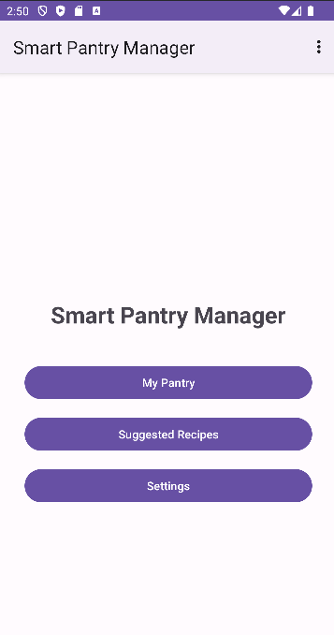

Smart Pantry Manager Navigation Menu:
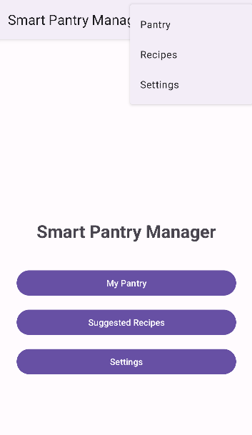

The Main Screen and navigation menu provide clear access to the main features of the application. This keeps navigation simple and allows the user to access the pantry, recipe suggestions and settings without complicated menus.

3.2 Pantry Management
The My Pantry screen allows the user to manage the ingredients that are currently available. Each pantry item contains an ingredient name, quantity, unit and an optional expiry date. The pantry information is stored in the SQLite database so that it remains available after the application is closed.
The user can add new pantry items and select an existing item to edit or delete it. Input validation is also used to prevent incomplete or invalid information from being saved.
My Pantry Screen:
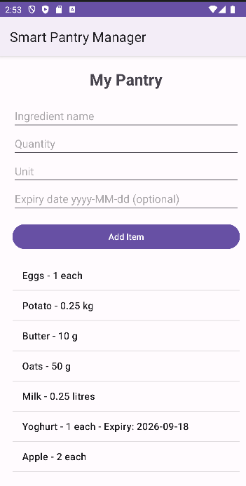
The above screenshot shows the saved pantry items together with the fields used to enter new ingredients. Quantities are displayed in a user-friendly format while still allowing decimal quantities such as 0.25 kg.

Adding a Pantry Item:
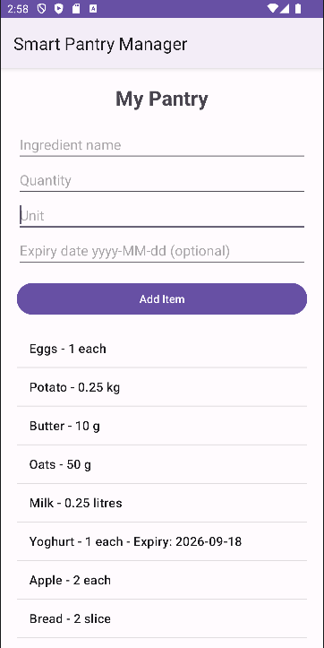

The above screenshot demonstrates the Add function. A new Bread item was entered and successfully added to the pantry.

Editing a Pantry Item:
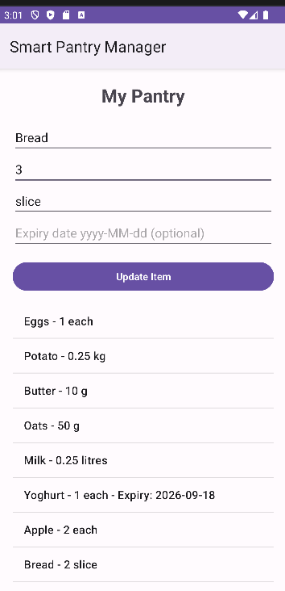

The above screenshot demonstrates the Edit function. When an existing pantry item is selected for editing, its information is loaded into the input fields and the Add Item button changes to Update Item. The quantity can then be changed and saved.

Deleting a Pantry Item:
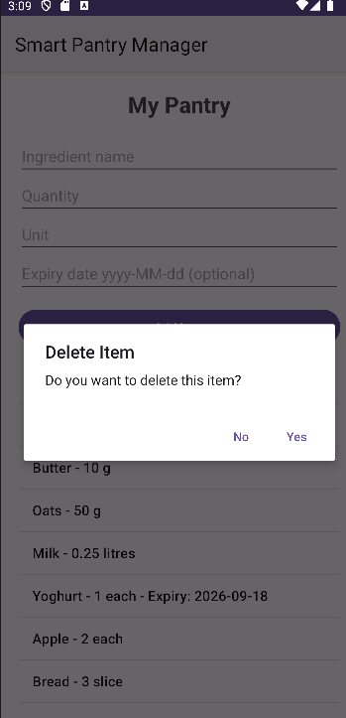

The above screenshot shows the confirmation dialog displayed before an item is deleted. This helps prevent a pantry item from being removed accidentally.

Pantry Input Validation:
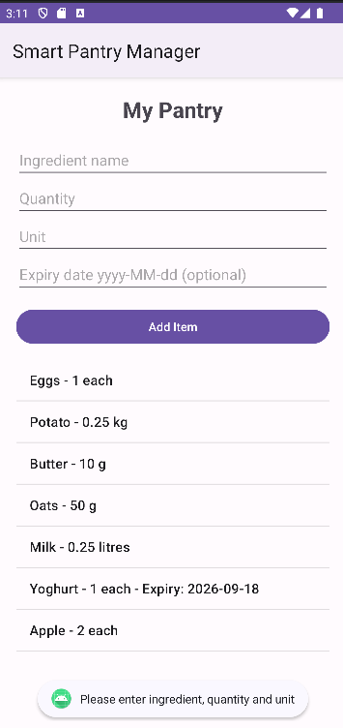

The above screenshot demonstrates input validation. When the user attempts to add an item without entering the required ingredient name, quantity and unit, the application displays a message and does not save the item.

3.3 Recipe Collection and Matching
The Smart Pantry Manager contains a collection of recipes stored in the SQLite database. Each recipe contains a recipe name, the required ingredients and quantities, and preparation steps.
The RecipeMatcher class compares the ingredients required for each recipe with the ingredients currently stored in the pantry. A recipe is only suggested when every required ingredient is available in a sufficient quantity.
The matching process also handles simple differences in ingredient names, such as Egg and Eggs, and basic unit conversions such as kilograms to grams and litres to millilitres. This allows the application to perform strict matching while still handling common differences in how pantry quantities are entered.

Suggested Recipes:
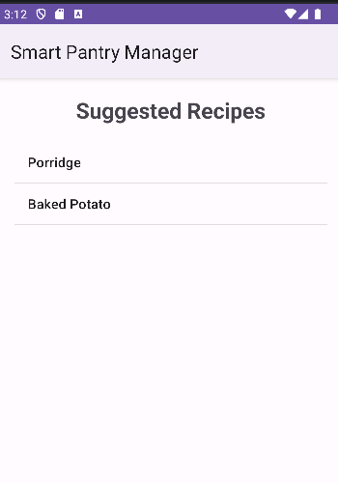

The above screenshot shows the recipes that can be prepared using the ingredients currently available in the pantry. In this example, the application identified Porridge and Baked Potato as valid matches.

Recipe Details:
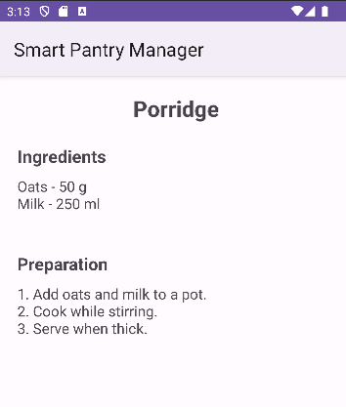

When a recipe is selected, the Recipe Details screen displays the required ingredients, quantities and preparation instructions. Figure 11 shows the details for the Porridge recipe, which requires 50 g of oats and 250 ml of milk.

No Matching Recipes:
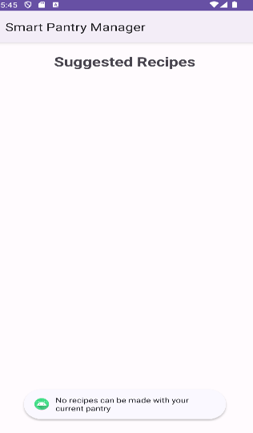

The above screenshot demonstrates strict recipe matching. For this test, the available quantities of oats and potato were temporarily reduced so that the pantry did not contain enough ingredients to complete any recipe. The application displayed the message “No recipes can be made with your current pantry” instead of displaying partial recipe matches.

3.4 Settings and Expiry Alerts
The Smart Pantry Manager includes a Settings screen that allows the user to turn expiring-soon alerts on or off. The selected setting is stored using SharedPreferences, which allows the application to remember the user's choice after the application is closed and reopened.
When the alert setting is enabled, the application checks pantry items that contain an expiry date. If an item is approaching its expiry date, an alert is displayed when the application opens. This feature helps the user identify ingredients that should be used soon and supports the purpose of reducing food waste.
Expiring Soon Alert Setting:
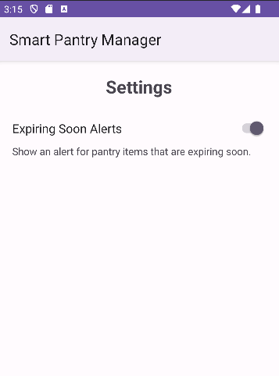

The above screenshot shows the Settings screen with Expiring Soon Alerts enabled. The switch allows the user to control whether expiry alerts should be displayed.

Expiry Alert:
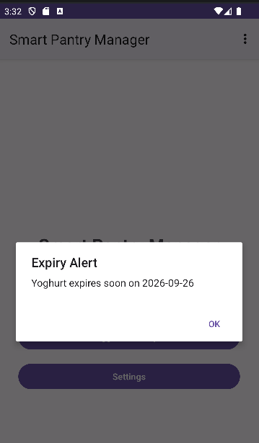

The above screenshot demonstrates the expiry alert. The Yoghurt pantry item was given an expiry date of 26 September 2026. The application detected that the item was expiring soon and displayed an alert containing the ingredient name and expiry date.

3.5 SQLite Database and Data Persistence
The Smart Pantry Manager uses an SQLite database named SmartPantry.db to store application data locally on the Android device. SQLite was used because it provides simple local storage and does not require an external database server or internet connection (SQL Mapping, 2026).
The database is managed by the DatabaseHelper class, which extends SQLiteOpenHelper. The database contains three tables: pantry, recipes and recipe_ingredients.
The pantry table stores the ingredient name, quantity, unit and optional expiry date entered by the user. The recipes table stores the recipe name and preparation steps, while the recipe_ingredients table stores the ingredients, quantities and units required for each recipe.
The pantry data supports Create, Read, Update and Delete operations. Because the information is stored in SQLite, pantry items remain saved when the application is closed and reopened.
SmartPantry.db Viewed in Android Studio Database Inspector:
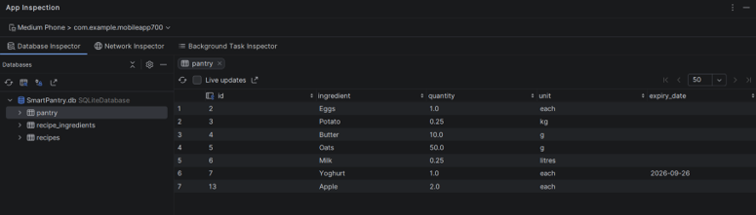

The above screenshot shows the SmartPantry.db database in Android Studio's Database Inspector. The stored pantry records can be viewed directly in the pantry table. The recipes and recipe_ingredients tables are also stored in the same database.

4. Testing and Application Output
The Smart Pantry Manager was tested throughout development to ensure that the main functions worked correctly. Testing included pantry CRUD operations, input validation, recipe matching, unit conversion, expiry alerts and data persistence. The following table summarises the main tests performed and their results.
Test | Expected Result | Actual Result | Status
Add pantry item | New ingredient is added and displayed | Item was added and displayed correctly | Pass
Edit pantry item | Selected item can be updated | Item was updated successfully | Pass
Delete pantry item | Selected item is removed after confirmation | Item was deleted successfully | Pass
Empty required fields | Application prevents item from being saved | Validation message was displayed | Pass
Invalid quantity | Quantity of 0 or less is rejected | Invalid quantity was not accepted | Pass
Invalid expiry date | Incorrect date format is rejected | Invalid date was not accepted | Pass
Strict recipe matching | Only complete recipe matches are displayed | Only recipes with sufficient ingredients were displayed | Pass
Insufficient ingredients | Recipe is excluded | Recipe was not displayed | Pass
Singular/plural matching | Egg and Eggs can be matched | Ingredient names matched correctly | Pass
Unit conversion | Compatible units such as kg/g and litres/ml are compared | Quantities were converted and matched correctly | Pass
No matching recipes | User receives a message | “No recipes can be made with your current pantry” was displayed | Pass
Expiry alert | Expiring item produces an alert when enabled | Expiry alert was displayed correctly | Pass
Settings persistence | Alert setting remains saved | Selected setting remained saved | Pass
Database persistence | Pantry data remains after closing and reopening app | Saved pantry items remained available | Pass
The testing confirmed that the main functions of the application operated as expected. The CRUD functions successfully stored and modified pantry data, while validation prevented invalid information from being entered. Strict recipe matching prevented incomplete recipes from being suggested, and the SQLite database successfully maintained the stored data between application sessions.

5. Important Code Snippets
The following code snippets show some of the important functions used in the Smart Pantry Manager application. The selected code demonstrates database storage, input validation, recipe matching and navigation.
5.1 SQLite Database and CRUD:
The DatabaseHelper class is responsible for creating and managing the SQLite database. It also contains the methods used to add, read, update and delete pantry items. The following code shows how a new pantry item is added to the database (SQLite DB, 2022).
// This adds an item to the pantry
public boolean addPantryItem(String ingredient, double quantity,
String unit, String expiryDate) {
SQLiteDatabase db = this.getWritableDatabase();
ContentValues values = new ContentValues();
values.put("ingredient", ingredient);
values.put("quantity", quantity);
values.put("unit", unit);
values.put("expiry_date", expiryDate);
long result = db.insert("pantry", null, values);
return result != -1;
}

Code Snippet 1: Adding a Pantry Item to SQLite
This method receives the pantry information entered by the user and stores it in a ContentValues object. The insert() method then adds the information to the pantry table. The method returns true when the item is successfully added and false if the insert fails.

5.2 Input Validation
Input validation is used in PantryActivity to make sure that valid information is entered before a pantry item is saved. The ingredient name, quantity and unit are required fields. The quantity must also be greater than zero.
// This checks the required fields
if (ingredient.isEmpty() || quantity.isEmpty() || unit.isEmpty()) {
Toast.makeText(
PantryActivity.this,
"Please enter ingredient, quantity and unit",
Toast.LENGTH_SHORT
).show();
return;
}
double quantityNumber = Double.parseDouble(quantity);
// This checks the quantity
if (quantityNumber <= 0) {
Toast.makeText(
PantryActivity.this,
"Quantity must be greater than 0",
Toast.LENGTH_SHORT
).show();
return;
}

Code Snippet 2: Pantry Input Validation
This code checks that the ingredient name, quantity and unit have been entered. If one of the required fields is empty, a Toast message is displayed and the item is not saved. It also checks that the entered quantity is greater than zero. The return statement stops the save operation when the information is invalid.

5.3 Strict Recipe Matching
The RecipeMatcher class checks whether each recipe can be prepared using the ingredients currently stored in the pantry. A recipe is only added to the suggested recipes when all of its required ingredients are available in sufficient quantities.
// This checks the ingredient name and unit
if (sameIngredient(pantryIngredient, neededIngredient) &&
sameUnitType(pantryUnit, neededUnit)) {
double pantryAmount =
convertQuantity(pantryQuantity, pantryUnit);
double neededAmount =
convertQuantity(neededQuantity, neededUnit);
// This checks if there is enough
if (pantryAmount >= neededAmount) {
ingredientFound = true;
break;
}
}
// The recipe cannot be made if an ingredient is missing
if (!ingredientFound) {
canMakeRecipe = false;
break;
}
// This adds the recipe if all ingredients are available
if (canMakeRecipe) {
matchingRecipes.add(recipeName);
}

Code Snippet 3: Strict Recipe Matching
This code compares each required recipe ingredient with the ingredients available in the pantry. It checks the ingredient name and unit before comparing the quantities. The quantities are converted to common units where necessary. If an ingredient is missing or the available quantity is too small, the recipe is excluded. The recipe is only added to the matching list when all required ingredients are available.

5.4 Navigation Using Intents
Android Intents are used to navigate between the different screens of the Smart Pantry Manager. The following code shows how the My Pantry button opens the PantryActivity (GitBook, 2026).
// This button opens the pantry screen
btnPantry.setOnClickListener(new View.OnClickListener() {
@Override
public void onClick(View view) {
Intent intent = new Intent(
MainActivity.this,
PantryActivity.class
);
startActivity(intent);
}
});

Code Snippet 4: Navigation Using an Intent
This code adds a click listener to the My Pantry button. When the user selects the button, an Intent is created that connects MainActivity to PantryActivity. The startActivity() method then opens the My Pantry screen. The same method is also used to open the Suggested Recipes and Settings screens.

6. Challenges and Solutions
During the development of the Smart Pantry Manager, several challenges were experienced and solved during testing.
One challenge was matching ingredients when different units were used. For example, the pantry could contain 0.25 kg of potato while a recipe required 250 g. This was solved by converting compatible quantities into common units before comparing them.
Another challenge was handling simple differences in ingredient names. For example, a user could enter “Eggs” while a recipe contained “Egg”. The RecipeMatcher was updated to handle basic singular and plural ingredient names before comparing them.
Strict recipe matching was also important. Initially, the application needed to make sure that a recipe was not suggested when only some of its ingredients were available. This was solved by checking every required ingredient and only adding the recipe to the suggested list when all ingredients were available in sufficient quantities.
Another challenge was displaying quantities clearly. SQLite stores quantities as numbers such as 50.0, even when the value is a whole number. A simple formatting method was added so that whole numbers are displayed as 50, while decimal quantities such as 0.25 are still displayed correctly.
These challenges helped improve the reliability and usability of the final application.

7. Conclusion and Reflection
The Smart Pantry Manager was successfully developed as a Java Android application that allows users to manage pantry ingredients and receive recipe suggestions based on the ingredients they already have available. The application includes pantry CRUD functions, strict recipe matching, recipe details, input validation, expiry alerts, settings and SQLite data storage.
Developing the application provided practical experience with Android Studio, Java, XML layouts, Activities, Intents, ListViews, custom adapters and SQLite databases. Testing the application also showed the importance of validating user input and correctly handling ingredient names, quantities and different measurement units.
Overall, the project achieved the main requirements of the Smart Pantry Manager assignment. The application provides a simple way to manage pantry ingredients and helps users identify recipes that can be prepared without requiring ingredients that are not available.

References:
Activities (2026) Introduction to Activities and Android application development. Available at: https://developer.android.com/guide/components/activities/intro-activities (Accessed: September 20, 2026).
Android (2026) Android Simply Easy Learning. Available at: https://www.tutorialspoint.com/android/index.htm (Accessed: September 26, 2026).
Android Tutorial (2026) Android Tutorial | GeeksforGeeks. Available at: https://www.geeksforgeeks.org/android/android-tutorial/ (Accessed: September 26, 2026).
GitBook (2026) 2.1: Understanding Activities and Intents · GitBook. Available at: https://google-developer-training.github.io/android-developer-fundamentals-course-concepts/en/Unit%201/21_c_understanding_activities_and_intents.html (Accessed: September 26, 2026).
SQL Mapping (2026) Using the Room framework as SQL object mapping library. Available at: https://www.vogella.com/tutorials/AndroidSQLite/article.html (Accessed: September 18, 2026).
SQLite DB (2022) Android SQLite Database Example Tutorial | DigitalOcean. Available at: https://www.digitalocean.com/community/tutorials/android-sqlite-database-example-tutorial (Accessed: September 18, 2026).

